✴

**Document an existing experience**

**customer journey map -Real time river water quality monitoring and control system**

Team ID:PNT2022TMID41871

#### Narrow your focus to a specific scenario or process within an existing product or service. In the **Steps** row, document the step-by-step process someone typically experiences, then add detail to each of the other rows.

**TIP**

As you add steps to the experience, move each these “Five Es” the left or right depending on the scenario you are documenting.

**Customer experience journey map**

## Use this framework to better

**SCENARIO**

**Browsing, booking, attending, and rating a local city tour**

### Steps

**Entice**

How does someone initially become aware of this process?

# PREREQUISTE

What do people experience as they begin the process?

# PROJECT DESIGNING AND DEVELOPMENT

In the core moments in the process, what happens?

# BENEFITS

What do people typically experience

as the process finishes?

# OUTCOMES

What happens after the experience is over?

## understand customer needs, motivations, and obstacles by illustrating a key scenario or process from start to finish.

When possible, use this map to document and summarize interviews and observations with real people rather than relying on your hunches or assumptions.

Created in partnership with

getting data samples and making database

What does the person (or group) typically experience?

### Interactions

What interactions do they have at each step along the way?

**People:** Who do they see or talk to?

**Places:** Where are they?

**Things:** What digital touchpoints or physical objects would they use?

**making people to know about their actual problem**

they can feel the threats and disadvantages

**Usage of advanced technologies**

they feel curious about new technologies and applications

Getting to know about their problem and requirements

Advanced purity application

satisfaction of customers

sensor setup is made and design implementation is done according to the need

**checking for availability of technologies and their applications**

getting a deep knowledge about problems and available solutions

visiting the effected area and knowing updates

real time data access can be done by using remote monitoring and internet of things technology.data collected can be stored in IBM could .with the help of web IU we can get analysed data

to check water quality by analysing the parameters such as temperature ,pH and conductivity.by considering these requirements smart water monitoring system

river water quality monitoring and control system

easier usage model and accurate values

### Goals & motivations

customer requires the system consist of several sensors is used to measuring physical and chemical parameters of water

to make them aware of easy solutions for their problem

availability of clean drinking water in rural areas

making people accessible with edible drinking water

creating a control and monitoring river water quality system which is having accuracy for customers need

clean drinking water

At each step, what is a person’s primary goal or motivation? (“Help me...” or “Help me avoid...”)

This is a title...

**Positive moments**

this project has been successful in addressing the problems that needed to be resolved and have several applications

seeing people ready for change and development

safe drinking water

automatic control and IOT based application

the aim of this project is to give an application which can be easily operated and give real time information

What steps does a typical person find enjoyable, productive, fun, motivating, delightful, or exciting?

##### [Share template feedback](https://muralco.typeform.com/to/CiqaHVat?typeform-source=app.mural.co)

**Negative moments**

What steps does a typical person find frustrating, confusing, angering, costly, or time-consuming?

seasonal changes

to test more parameters of the water quality for some applications

the major drawback of this system is high initial costs and complex structure

implementation process taking more time

the sensors are operated on a power source which might requires to be replaced in case of malfunctioning

**Areas of opp**T**o**h**rt**i**u**s**n**is**it**a**y** title...

can have real time data values

the system has wide applications and it is usable by all categories of users

this will create more opportunities for people in rural area

The design and demonstration of a prototype remote

,automatic,and low cost water quality monitoring system creating a

the monitoring system need a executive care and technical support

How might we make each step

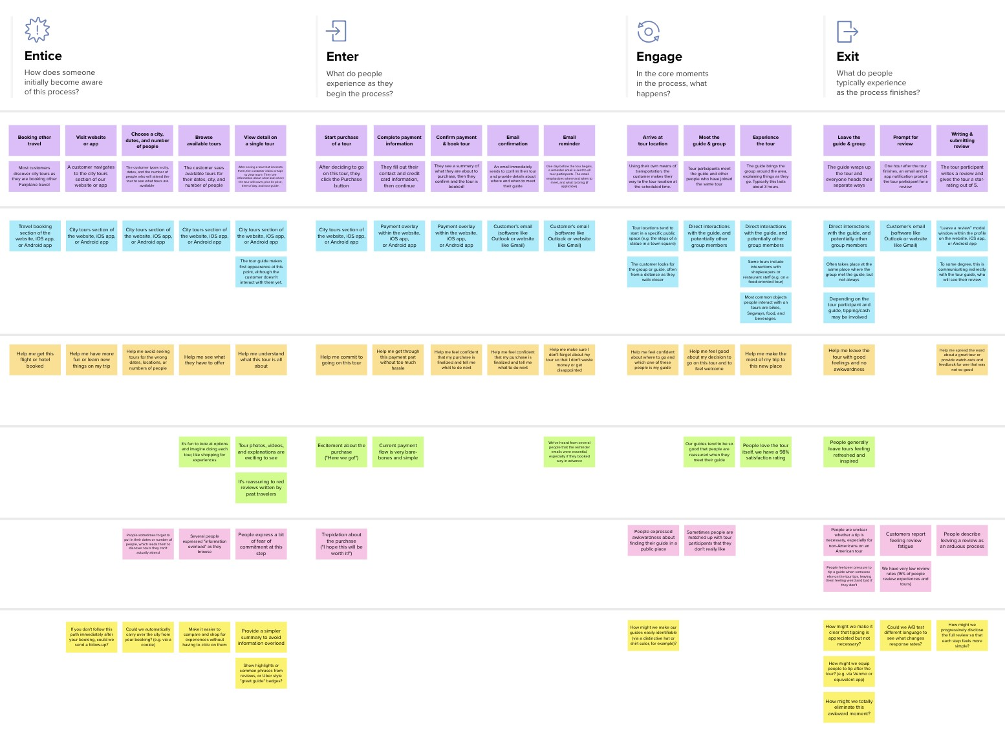

**Template**

**Need some inspiration?**

See a finished version of this template to kickstart your work.

[**Open example**](https://app.mural.co/template/f59f644b-b4b4-47b5-9ed6-3a8c71ceb612/896b31fe-5597-40ef-9b06-3811a1a45ace)